Redistricting debate far from over
BY JOHN BAYLES

February 23, 2012

If the Republican-controlled New York State Senate moves forward with its current redistricting plan, it’s sure to be vetoed by Governor Andrew Cuomo. According to NYS Senator Daniel Squadron, who could see his district sliced and diced under the current proposal, the Governor has already promised to use the power of his pen to make sure the plan doesn’t move beyond his desk.
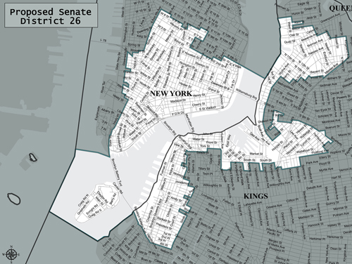
The proposed 2012 map for Senate District 26, released by the Legislative Task Force for Demographic Research and Reapportionment. Under the Republican plan NYS Sen. Daniel Squadron would lose Battery Park City and portions of Tribeca that he has represented since he was elected.
And as for the New York State Assembly, Speaker Sheldon Silver said though a plan has been released, it is “not a final plan as far as the Assembly is concerned.”

The Assembly plan has not garnered anywhere near the amount the criticism the Senate plan has. For example, Silver’s district would see essentially no change in boundaries when compared to Squadron’s. Asked about the Senate proposal, Silver said it came down to continuity and that the Assembly has made good on a promise to keep all districts within a three percent deviation. Under the current Assembly plan, only one of its 150 districts that would deviate beyond the three percent margin.

“The Senate Republican plan is out there, and it’s being criticized for being shockingly political and self-serving and the Governor has said he is going to veto it,” said Squadron on Tuesday.

Under the current plan, Squadron would lose Battery Park City and portions of Tribeca.

“I am very proud to represent Battery Park City and the parts of Tribeca that I’d lose and that I feel a real connection to,” said Squadron. “I’d be very, very sorry not to have the chance to represent those communities anymore.”

Squadron described the Senate’s current plan as “a power grab” and the result of a process “culled by a majority desperately clinging to power.”

AD-064

